Lab-Project A2: Analyzing RAM with Volatility

What You Need for This Project
- A virtual machine running Kali Linux 2018.
- In Windows 10 the student should be using Volatility 3 and he might have to know how to capture a RAM image with FTK Imager.

Getting an image of Kali Linux 2018
- Go to link and download the vmdk for Kali Linux 2018.2.
- Extract the 7z file.
How to Get VMware Workstation 16 Pro
- Go to link and download Workstation 16 Pro for Windows.
- Run the installation with default options, removing the option to check for updates.
- When the installation finishes, instead of selecting Finish, select License and enter the license.
Creating a new virtual machine using the vmdk for Kali Linux 2018.2
- In VMware Workstation 16 Pro, select Create a New Virtual Machine.
- In the Welcome the New Virtual Machine Wizard screen, keep the default option of Custom (advanced) and select Next.
- In the Choose the Virtual Machine Hardware Compatibility screen, keep the default options and select Next.
- In the Guest Operating System Installation screen, keep the default option of “I will install the operating system later” and select Next.
- In the Select a Guest Operating System screen, keep the default options of Linux and Debian 10.x 64-bit and click Next.
- In the Name the Virtual Machine screen, change the Virtual machine name to KaliLinux 2018.2 and select Next.
- In the Processor Configuration screen, keep the default options and select Next.
- In the Memory for the Virtual Machine screen, keep the default options and select Next.
- In the Network Type screen, select Use network address translation (NAT) and select Next.
- In the Select I/O Controller Types screen, keep the default option of LSI Logic and select Next.
- In the Select a Disk Type screen, keep the default option of SCSI and select Next.
- In the Select a Disk screen, select Use an existing virtual disk and select Next.
- In the Select an Existing Disk screen, select Browse. Navigate to the location you extracted the vmdk file from step 2. Select Next. If you get a prompt asking to convert the existing virtual disk to newer format, select Keep Existing Format.
- In the Ready to Create Virtual Machine screen, select Finish.
Downloading the memdump
- Start your virtual machine with Kali Linux. Login with the following credentials:
Username: root
Password: osboxes.org
- Download the memdump from here.
Registry hives
- In Terminal Emulator, execute the following command:
volatility hivelist --profile=Win2008SP1x86 -f filepath
Remember to replace filepath in the command with the path to the memdump you extracted from the 7z file.
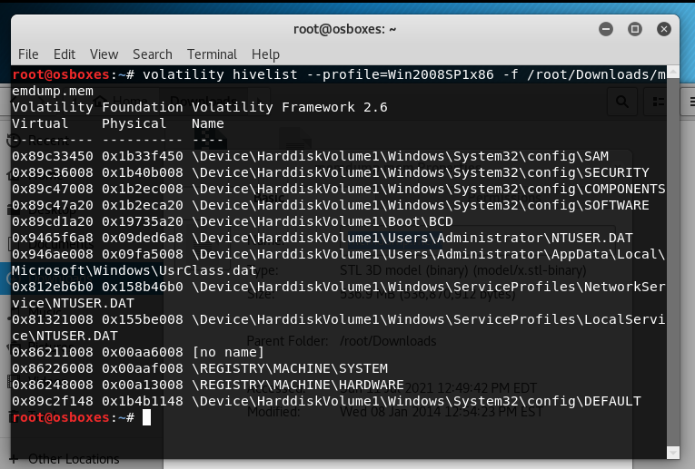
- Examine your output and find the two addresses outlined in green above: the virtual addresses of the SAM and SYSTEM hives. Those two hives together contain enough information to extract Windows password hashes.
Password hashes
- Notice that the two hexadecimal addresses you found above are used in this format:
-y SYSTEM -s SAM
- In Terminal Emulator, enter the following command:
volatility hashdump --profile=Win2008SP1x86 -f filepath -y 0x86226008 -s 0x89c33450
Remember to replace filepath in the command with the path to the memdump you extracted from the 7z file.
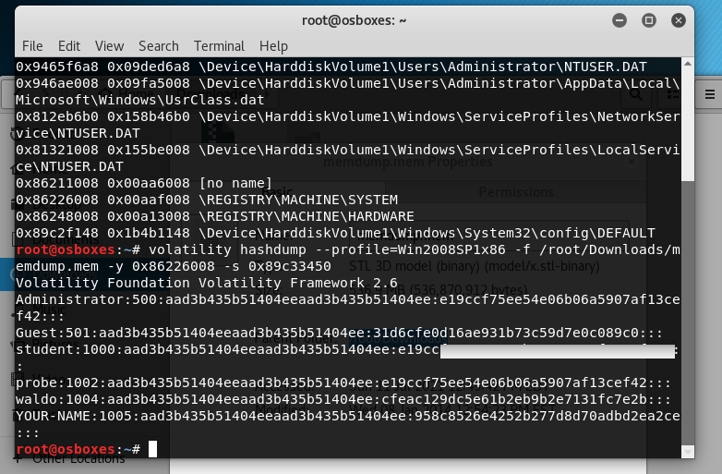
- When you get the command correct, you will see the login account names and hashed passwords, as shown below.
- Windows stores two hashes with each password, delimited by colons. The first one is an extremely insecure, obsolete hash using the LANMAN algorithm. Windows operating systems since Vista no longer use LANMAN hashes, so they are filled with a dummy value starting with "aad".
- The second hash is the newer NTLM hash, which is much better than LANMAN hashes, but still extremely insecure and much more easily cracked than Linux or Mac OS X hashes.
Cracking the password hashes
- In your Browser, go to link and copy the second hash for the user student to the form field. Select Crack hashes.
- You should be able to see the plain text password in the result box.
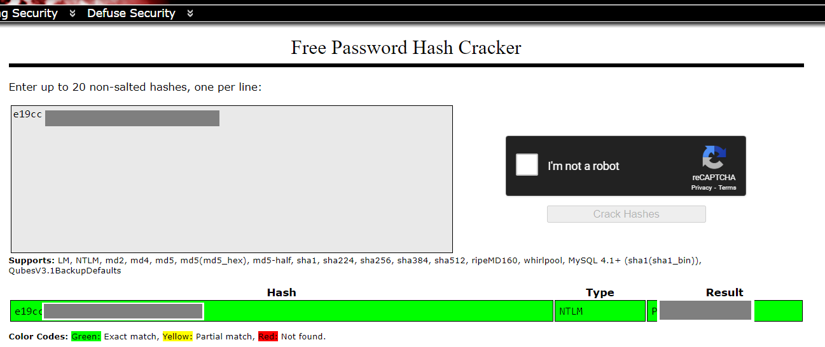

Saving a Screen Image
- Make sure your screen shows the plain text password you cracked. Refer to the screenshot above.
- Save the image with the filename Lab-ProjA2-YOURNAME.png. Use your real name, not the literal text YOURNAME.

Turning in your Project
- Submit the image to: cms with a subject line of Lab-ProjA2-YOURNAME, replacing YOURNAME with your real name.

